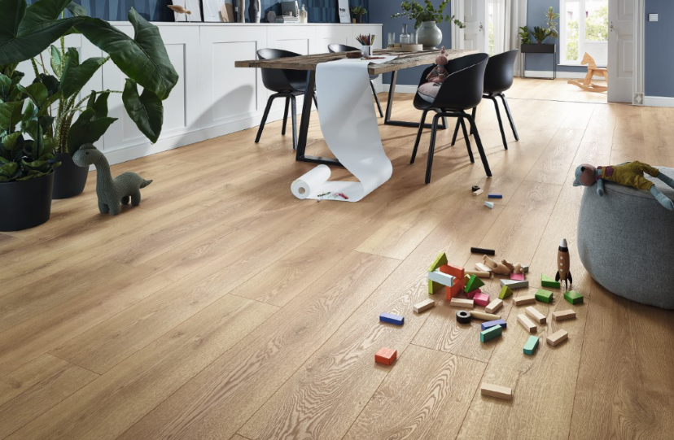
MAMMUT PLUS collection: D4725 Mountain Oak Nature
SWISS KRONO Group at DOMOTEX 2020:
Discovering our fascinating world of flooring
January 2020 – SWISS KRONO Group presents a variety of new decors for better quality of life and a more pleasing and comfortable room environment at this year’s DOMOTEX under the “ATMYSPHERE” motto. With its exclusive designs, SWISS KRONO Group offers its customers the option of individually designing their living spaces such that they are stylish and natural, and present a unique living environment – wholly in harmony with what is natural and sustainable. “We pick up the latest trends in appearance and feel and combine these with technological innovations,” says Georg Mäder, CSMO at SWISS KRONO Group. “This results in a new generation of premium flooring that appeals to consumers all around the globe.”
SWISS KRONO highlights at DOMOTEX 2020:
KRONOTEX Floors for living
The 2020 KRONOTEX collections from Germany present 45 new decors, four new synchronous structures, and a new tile surface. Extremely versatile oak in differing looks from calm, balanced decor images to rough, cracked surfaces remains very much in trend. Elegant appearance with a low proportion of sapwood sets the scene. Combined with authentic structures within a matt-in-matt look, this results in a natural decorative effect. This pleasingly balanced selection of various structures and looks is a fundamental reason why these collections are popular worldwide.
Six new tile designs, of which four are concrete variants, lead a new generation of the MEGA PLUS collection without a milled central joint, but with a circumferential micro-joint.

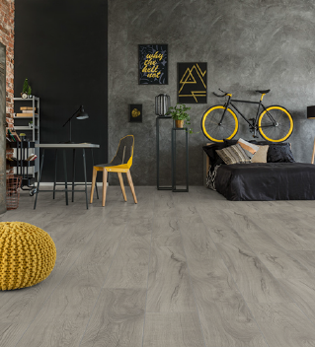  D4671 Magnum Oak Grey from  the MAMMUT PLUS collection | 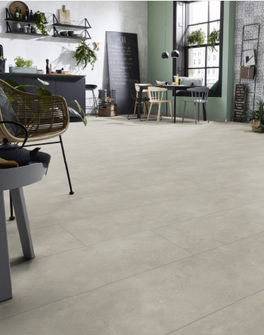  D4681 Loft Beige from the  MEGA PLUS collection
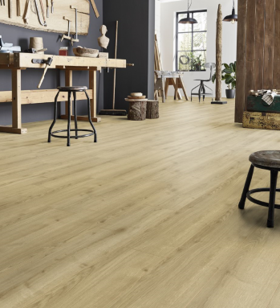  D4686 Adaja Oak from the  ROBUSTO collection | 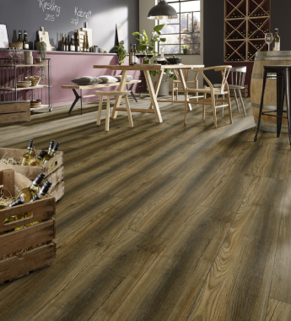  D4609 Port Oak from the  EXQUISIT collection
New KRONOSWISS decors
A total of 32 new decors with newly developed surface structures are available in the various collections offered by the SWISS KRONO Group location in Switzerland. The SWISS NOBLESSE V4 BRILLIANT collection will be launched: It features six impressive decors with a gloss finish for making the most of a room. The 10 mm thick SWISS LIFESTYLE collection has been comprehensively revamped including new synchronous surfaces. The latest decors in the GRAND SELECTION EVOLUTION collection, featuring a specially selected French Oak with deep structures, have a more dominant appearance. The LAKE VIEW long plank collection within the HELVETIC FLOORS range features attractive new synchronous surfaces.
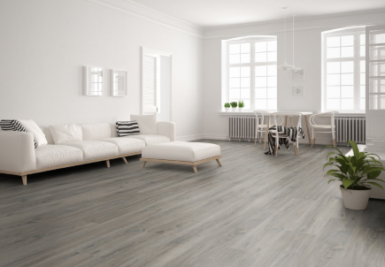  D4512 COPPER OAK from the GRAND SELECTION EVOLUTION collection | 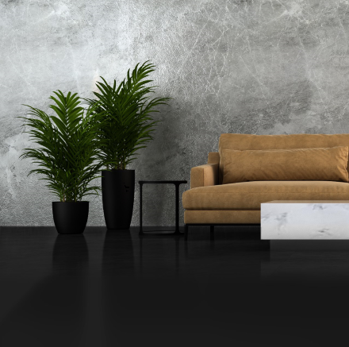  SWISS NOBLESSE V4  BRILLIANT | 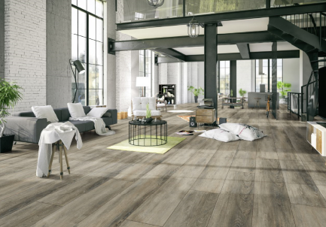  D4505 LAKE WALEN from the HELVETIC FLOORS collection

KRONOPOL: Latest PLATINIUM and AURUM generations
KRONOPOL floor coverings offer new formats, synchronous structures, and greater benefit to customers as well as over 40 new decors. More than half of the AURUM laminate flooring options are offered as AQUA ZERO, which are water-resistant products. KRONOPOL has 8 and 10 mm water-resistant décors alongside the 12 mm thick AQUA ZERO collection. All new AURUM products feature the AQUA PEARL locking system, which offers protection against liquids for at least 24 hours. Internal tests even show resistance of over three days. In addition, panels in the premium collection are now available in three different widths: 159 mm, 193 mm and 244 mm. A new length of 2025 mm will also be introduced.
Two chevron designs are the highlights in the PALOMA PLATINIUM collection.
Discussions with clients and architects are sources of inspiration for the new decors. In colour terms, this represents a return to natural oak tones and elegant wood grains that have a less dominant appearance. The technology behind the synchronous surfaces enables us to produce a high-quality product that is incredibly similar to real wood regarding its appearance and feel.

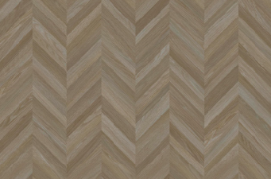  D4560 Kiko Oak from the PLATINIUM collection PALOMA  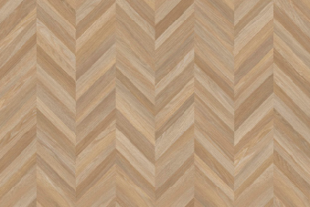  D4561 Carmen Oak from the PLATINIUM collection PALOMA | 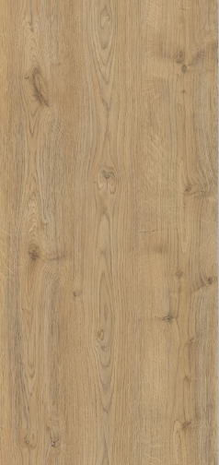  D4572 Libra Oak from the PLATINIUM collection ZODIAK

About SWISS KRONO Group
SWISS KRONO Group is one of the world’s leading manufacturers of wooden materials and stands for sustainable and innovative solutions in the home interiors, flooring, and building materials sectors. Founded as a family business in 1966, the Group now employs 5,100 staff worldwide. The headquarters are in Lucerne, Switzerland, and production takes place at ten sites in eight countries. SWISS KRONO Group has always had a relentless focus on quality and sustainability. The result: wood in its finest form.
Press contact
SWISS KRONO Group  Katja Hallbauer  Corporate Communication Manager  T +49 30 863 205 30  katja.hallbauer@swisskrono.com |  |  | SWISS KRONO Group  Fabian Kölliker  Head of Marketing  T +41 79 306 20 82  fabian.koelliker@swisskrono.com

