Temporary Facilities Built with Timber Modules: a Rehabilitation Centre and an Administrative Building for Deutsche Rentenversicherung
ERNE AG Holzbau Uses SWISS KRONO LONGBOARD OSB
May 2018 – Deutsche Rentenversicherung (DRV) in Germany is Europe’s largest state pension institution, with 57 million clients. Currently two of its facilities are being renovated and modernised: a rehab centre on the North Sea island of Norderney and an administrative building in Münster in Westphalia. In both cases, an interim building was needed for use while work was ongoing. The insurer places great stock in buildings that are economic and sustainable while also being highly functional. Prefabrication was therefore extensively used to build both of the structures.
While the main building of the rehabilitation clinic was being refurbished, DRV wanted to accommodate more than 30 patients elsewhere. “The goal was to complete the project on the island in a minimum of time,” says Gordon Bunk, who headed the project at ERNE AG Holz. “The client also wanted to very quickly erect a replacement for the administrative building in Münster that was designed for temporary use but nevertheless looked good and modern while blending harmoniously into its surroundings.”
Both projects were planned and implemented by the leading Swiss timber construction firm ERNE AG, which has acquired a reputation for innovative solutions involving modular, hybrid and lightweight steel construction as well as integrated window and building exterior systems. Specialising in high-end interior finishing solutions and traditional carpentry, the firm relies on a competent team of architects and specialist planners to create bespoke sustainable, eco-friendly buildings for temporary or long-term use.

The Client’s Request: Sustainable Natural Materials
It was important to the client to get a building that was sustainable and environmentally friendly, despite only being intended for temporary use. So it was only natural that wood should be chosen to make it. Hardly any other material boasts such a wide range of benefits. Modern timber construction makes use of eco-friendly engineered wood products and therefore not only conserves resources but also excels in terms of energy efficiency, thermal and acoustic insulation, fire protection and health living.
The choice of materials is especially important in clinics and other facilities where patients’ health is at stake. And eco-friendly engineered wood was just what the doctor ordered for this project: the clinic on Nordeney treats patients with respiratory diseases, allergies and dermatological problems. Wood and products derived from it are antistatic and antibacterial while breathing and regulating moisture to create a stable, healthy indoor climate that is conducive to greater wellbeing.

A Great Team: ERNE AG Holzbau and SWISS KRONO OSB
ERNE AG Holzbau used SWISS KRONO OSB products in the buildings. These two companies have enjoyed a good business relationship for many years. And they share the goals of innovation, sustainability and eco-friendliness. SWISS KRONO OSB uses completely formaldehyde-free binders while taking steps to ensure carbon neutrality. ERNE values this, as well as the products’ suitability for extensive prefabrication and special formats. Together, these properties ensure fast construction, sustainability and flexibility for meeting clients’ wishes. Prefabricated panels and modules crafted from SWISS KRONO OSB combine all of the advantages of modern timber construction – one of the many reasons why ERNE AG Holzbau has been using SWISS KRONO OSB for quite a few years.
SWISS KRONO OSB/4 is highly dimensionally stable and characterised by outstanding structural strength as well as excellent thermal and acoustic insulation and fire resistance. Because a railway line runs next to the administrative building, it was necessary to provide enhanced acoustic insulation. SWISS KRONO LONGBOARD OSB boards with a length of 15 metres were used in the rehab centre and 13 metres in the administrative building. These large formats enable modules without any butt joints over their entire length, which eliminates the need to cut to size and join multiple OSB boards and therefore speeds work. “The demand for these large formats is growing by leaps and bounds,” says Uwe Jöst, Managing Director of SWISS KRONO GmbH. “For customers like ERNE AG Holzbau, we have developed and implemented a special system for transporting boards up to 18 metres long. As far as we know, we’re the only ones in the world to have achieved this.” SWISS KRONO OSB/4 also boasts extremely low swelling and shrinkage as a result of fluctuating moisture levels.
Designed for normal loads, SWISS KRONO OSB/3 delivers excellent value for money. This sturdy, eco-friendly engineered wood product is excellently suited for loadbearing and reinforcing uses in construction, as well as for packaging and furniture.
SWISS KRONO OSB is made exclusively using thinnings from sustainably managed forests.
A Logical Challenge for the Rehab Centre: Transport of Modules to a North Sea Island
The interim facility was assembled from 40 timber modules with total usable floor space of 1,000m² on two storeys. But how do 40 prefabricated modules get from Switzerland to Norderney, a North Sea island nearly 1,000 kilometres away? Moving the modules from Aargau in Switzerland to the far north was a genuine logistical challenge. After being 70% prefabricated in Switzerland, they were taken by lorry to Hünxe in the German state of North Rhine-Westphalia. There they were fitted with plumbing and other systems before resuming their journey by ferry. The only real challenge after disembarking was complying with the island’s strict transport regulations, which limit the maximum permissible loaded weight to six tonnes per vehicle. This was accomplished by breaking the larger modules down into smaller ones to be reassembled on-site. In this way, it was possible to ferry ten modules to the island each day. Final assembly took just four days.
Good-Looking: Striking Wood Exteriors with Colourful Accents
The two buildings closely resemble one another on the outside. Both in Münster and on Norderney, the green- and blue-accented timber exteriors of the strictly cubic structures blend smoothly into their surroundings. This was a clever way to integrate DRV’s official colours into the architecture.

Facts at a Glance
Building types | Interim administrative building in Münster with total floor space of 2,400m² on three storeys  Interim rehab centre on Norderney with 34 patient beds on floor space of nearly 1,000m² on two storeys
Owner/builder | Deutsche Rentenversicherung Westphalia  Gartenstrasse 194, DE-48147 Münster
Year built | 2016
Planning / architects | Deutsche Rentenversicherung Westphalia /  ERNE AG Holzbau
Prefabricated and built by | ERNE AG Holzbau  Werkstrasse 3, CH-5080 Laufenburg  www.erne.net
Material used for administrative building (floors, ceilings and roof) | SWISS KRONO OSB/4 BAZ, sanded  13,050 x 2,810 x 25mm / 4,200 m²  SWISS KRONO OSB/3 EN 300, straight-edged  3,500 x 2,500 x 15mm / 4,500m²  = approx. 173m³ of OSB – equivalent to about 173 tonnes of stored carbon dioxide
Material used for interim rehab centre (walls and roof) | SWISS KRONO OSB/4 BAZ, sanded  15,000 x 2,810 x 25mm / 3,030m²  SWISS KRONO OSB/3 EN 300, straight-edged  3,500 x 2,500 x 15mm / 1,050m²  SWISS KRONO DP50  2,500 x 675mm / 450m²  = about 92m³ of OSB and 7m³ of DP50 – equivalent to about 100 tonnes of stored carbon dioxide

Images
The following images are available for downloading in print-ready resolution and may be used in publications free of charge provided they are credited as follows: © ERNE AG Holzbau | photograph: Jan Meier, Bremen

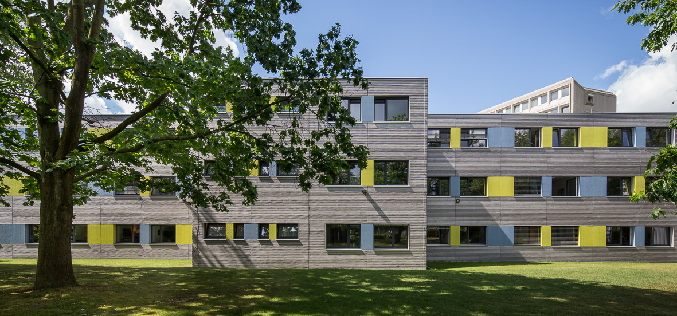
The new administrative building of Deutsche Rentenversicherung in Münster, accentuated with the insurer’s official colours (© ERNE AG Holzbau | photograph: Jan Meier, Bremen)
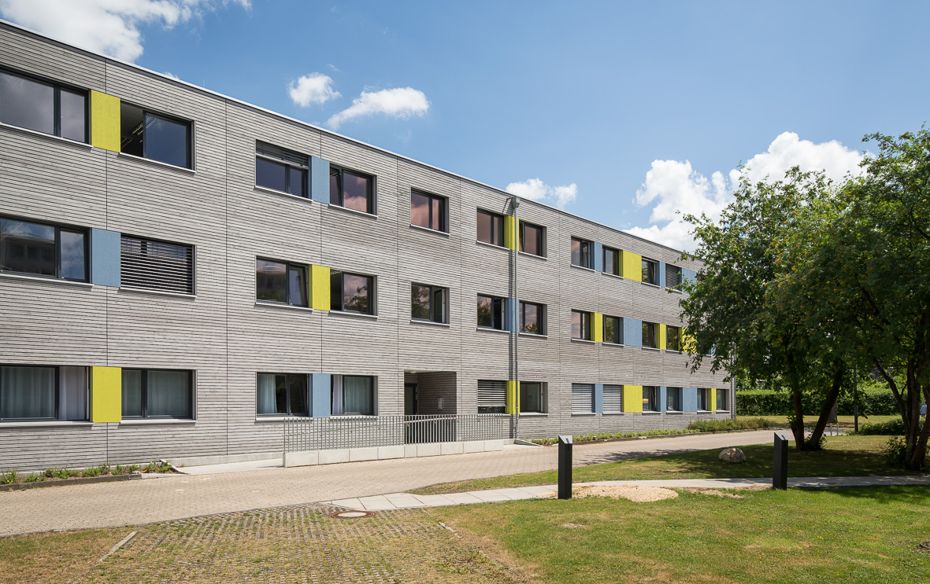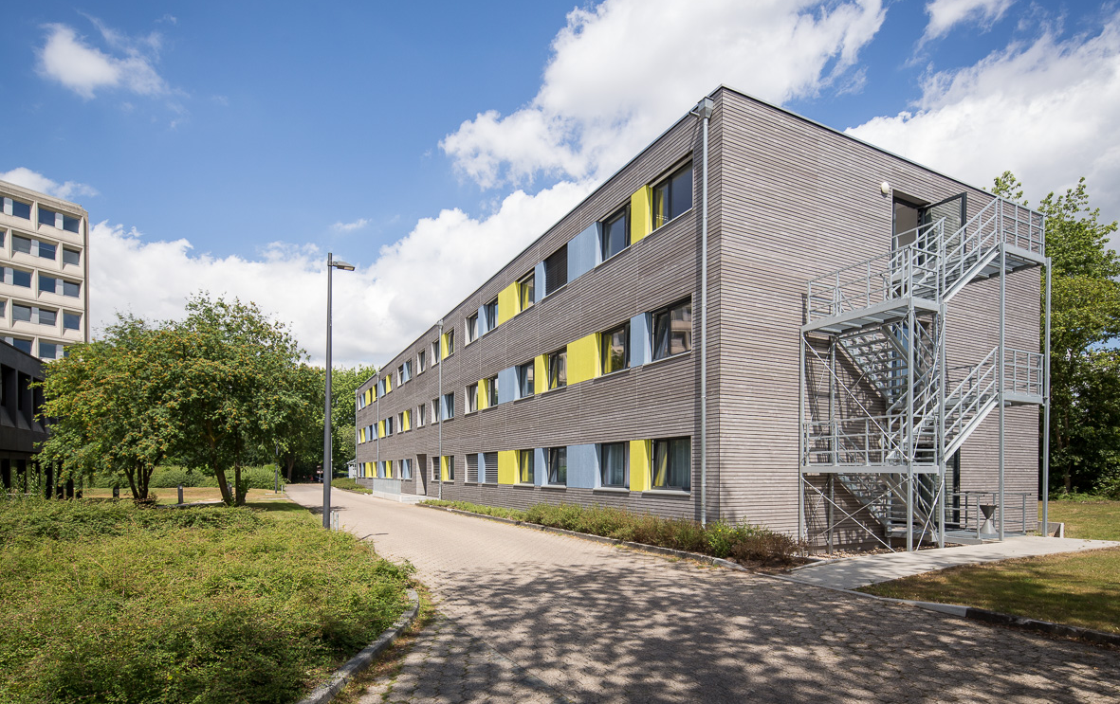
Aesthetic and functional: the DRV Verwaltungsgebäude in Münster wood exteriors and steel fire escape (© ERNE AG Holzbau | photograph: Jan Meier, Bremen)
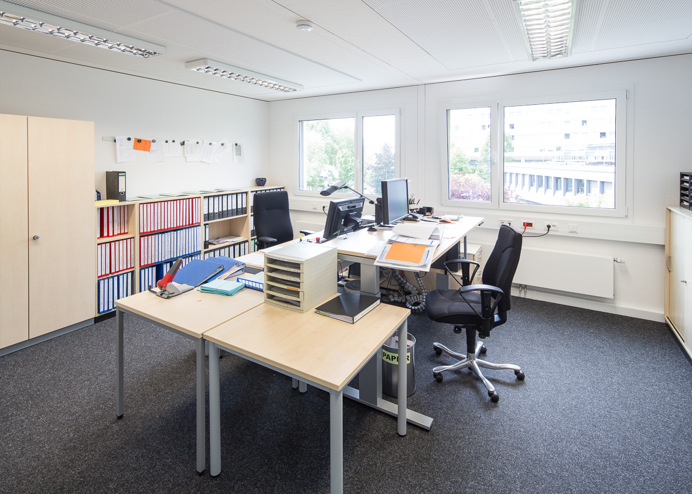 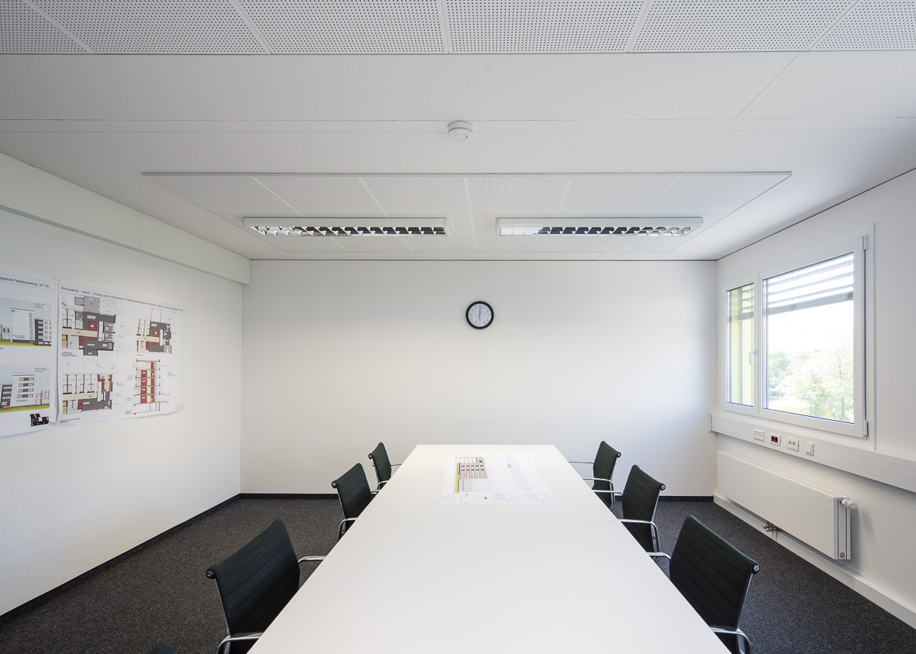
Bright and friendly: offices of the temporary administrative building in Münster
(© ERNE AG Holzbau | photograph: Jan Meier, Bremen)
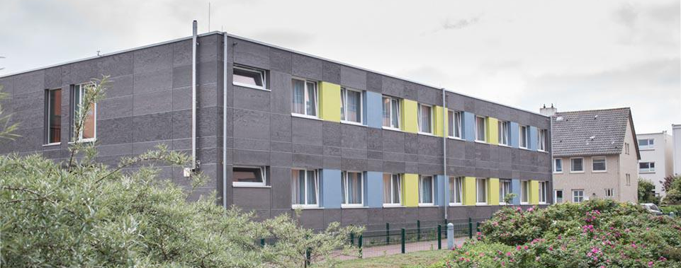
The temporary building for the rehab centre: a combination of prefabricated modules and panels
(© ERNE AG Holzbau | photograph: Jan Meier, Bremen)
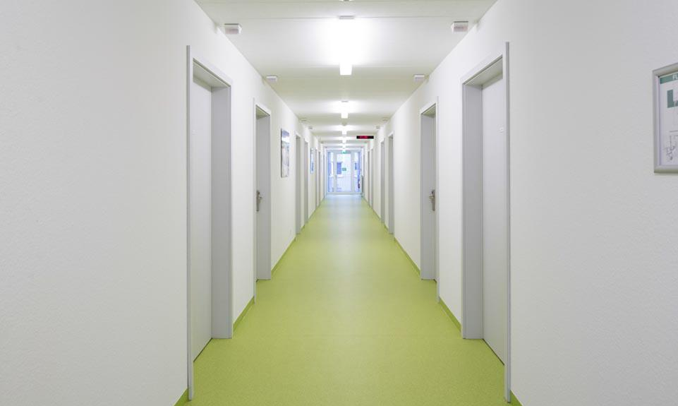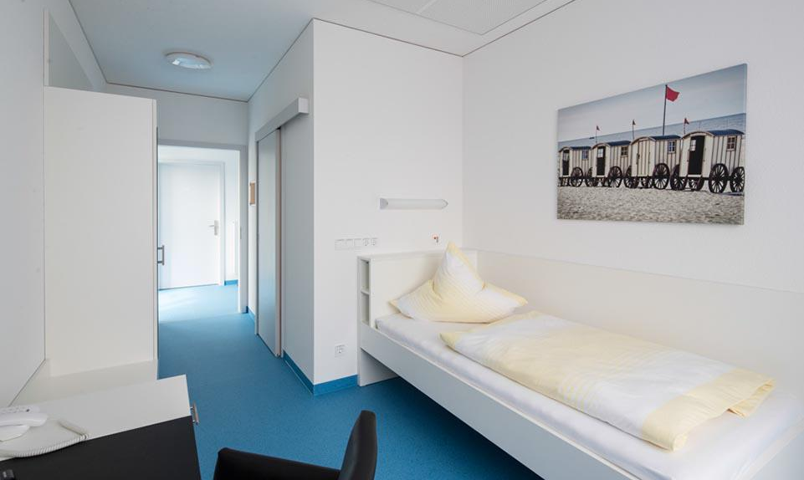
The clear, modern interior of the rehab centre
(© ERNE AG Holzbau | photograph: Jan Meier, Bremen)
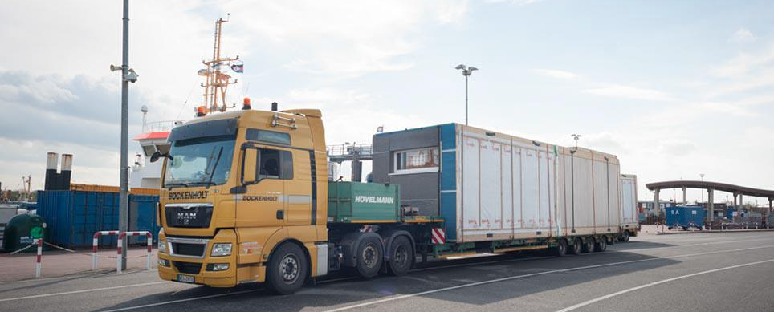
One of a total of 40 modules on the way to Norderney
(© ERNE AG Holzbau | photograph: Jan Meier, Bremen)
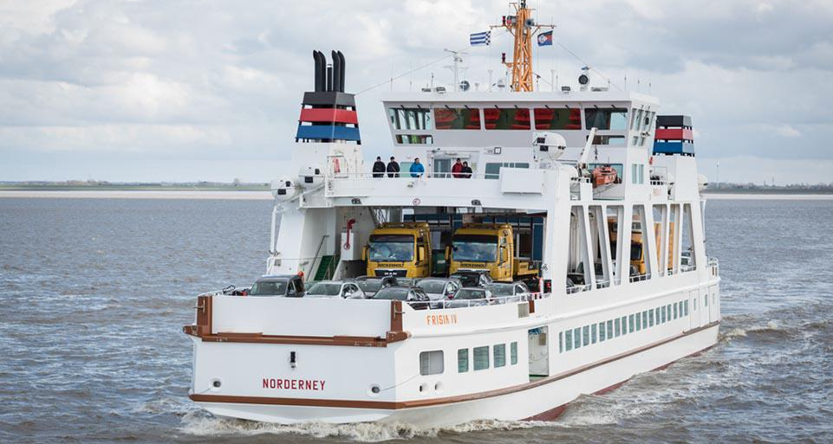
The lorries were not allowed to weigh more than six tonnes for crossing to Nordeney on the ferry (© ERNE AG Holzbau | photograph: Jan Meier, Bremen)
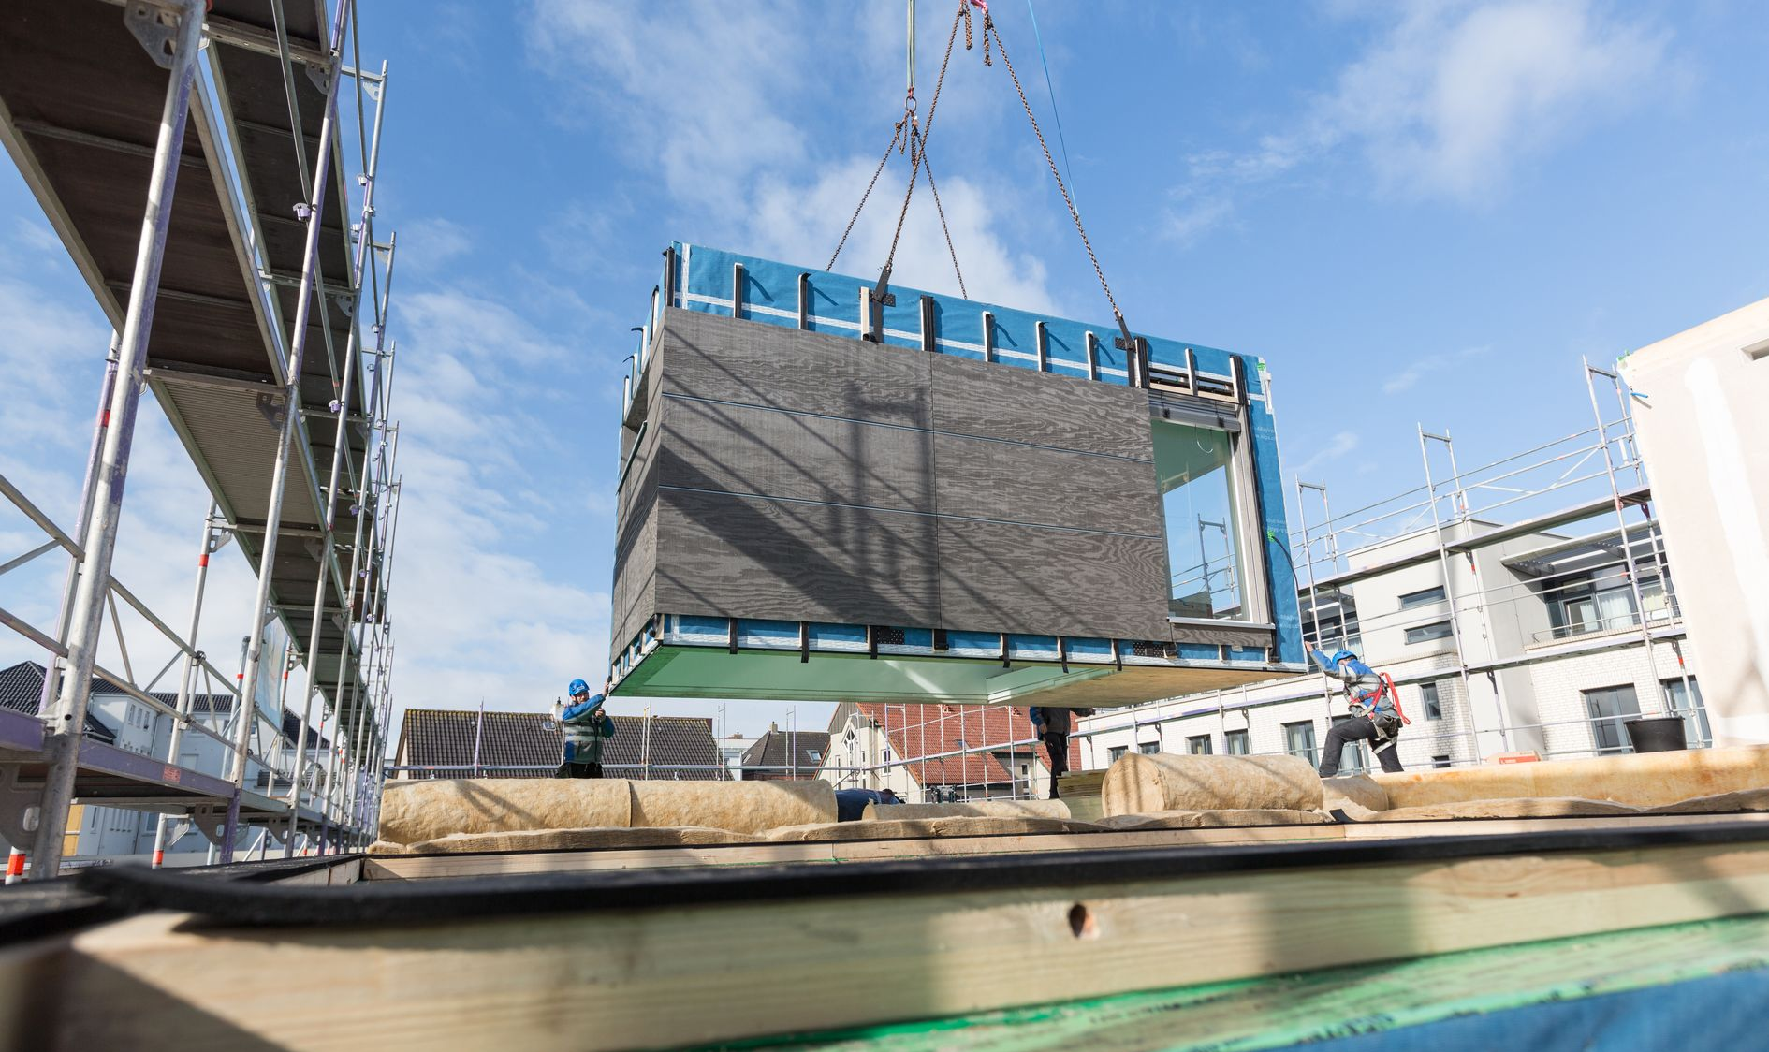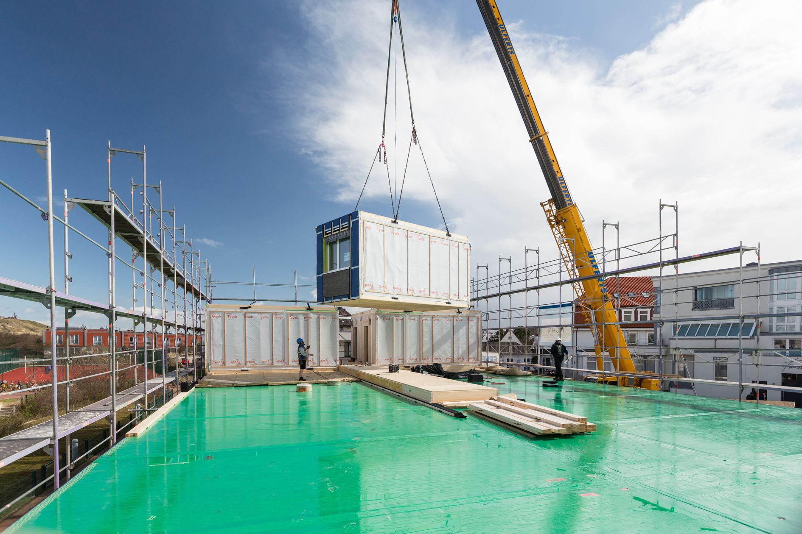
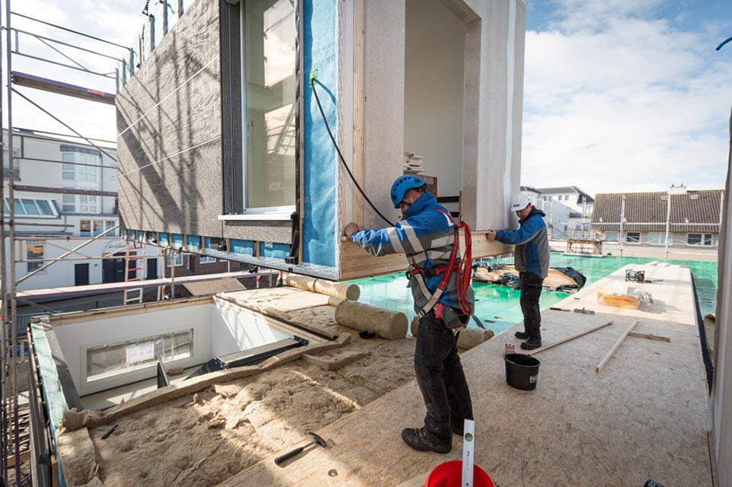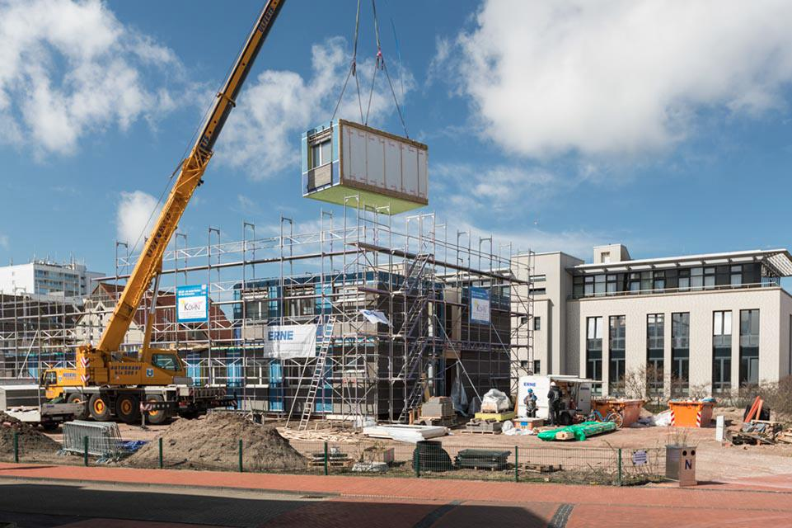
Piece by piece, the rehab centre was skilfully assembled from individual modules
(© ERNE AG Holzbau | photograph: Jan Meier, Bremen)
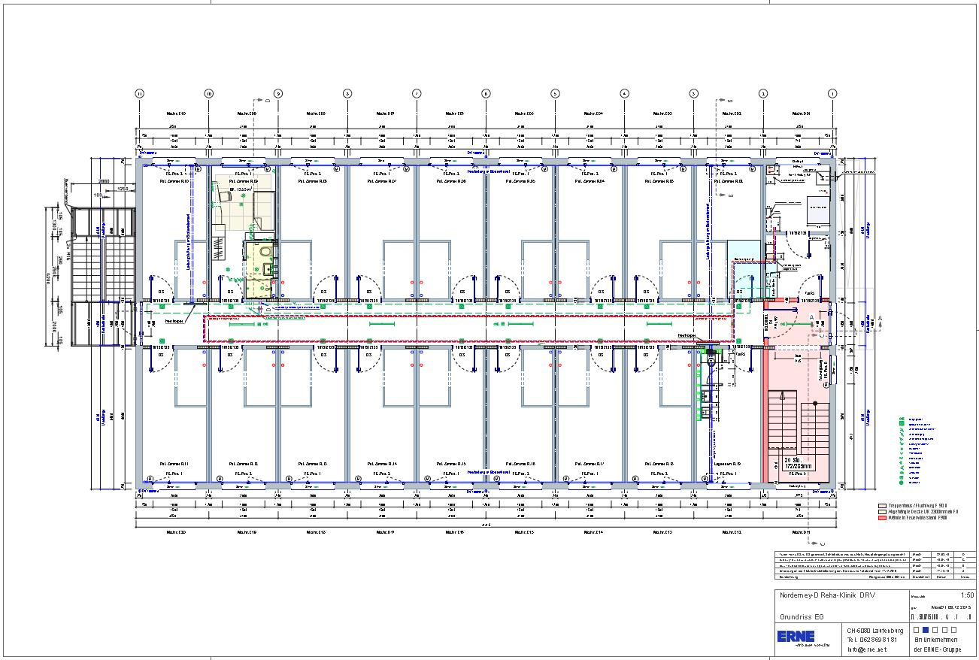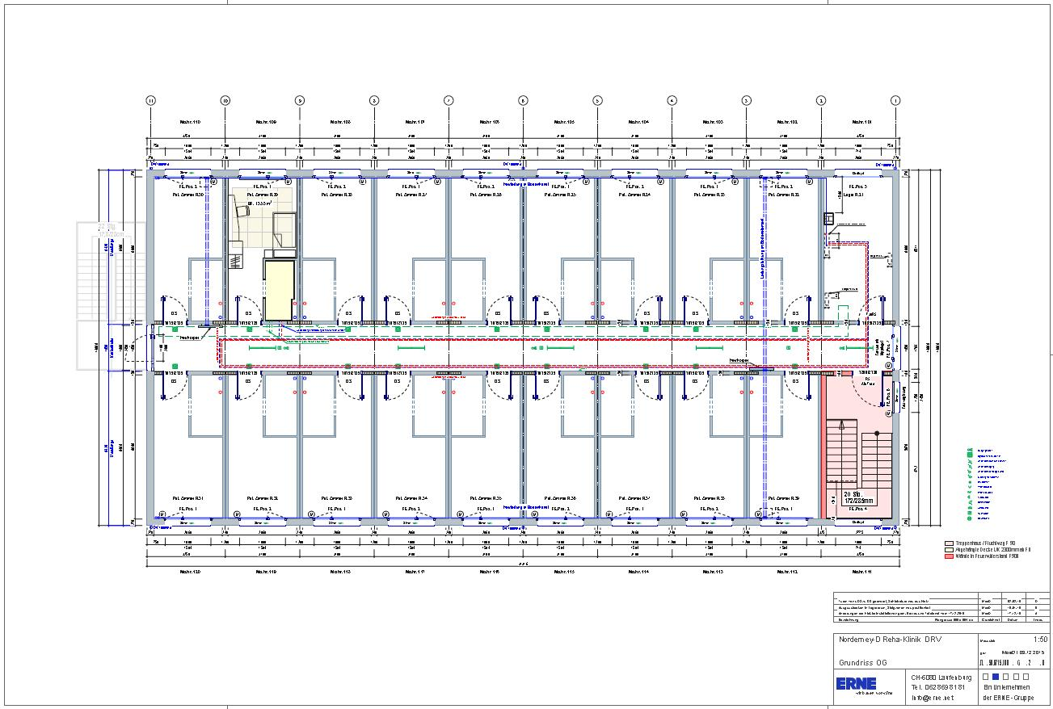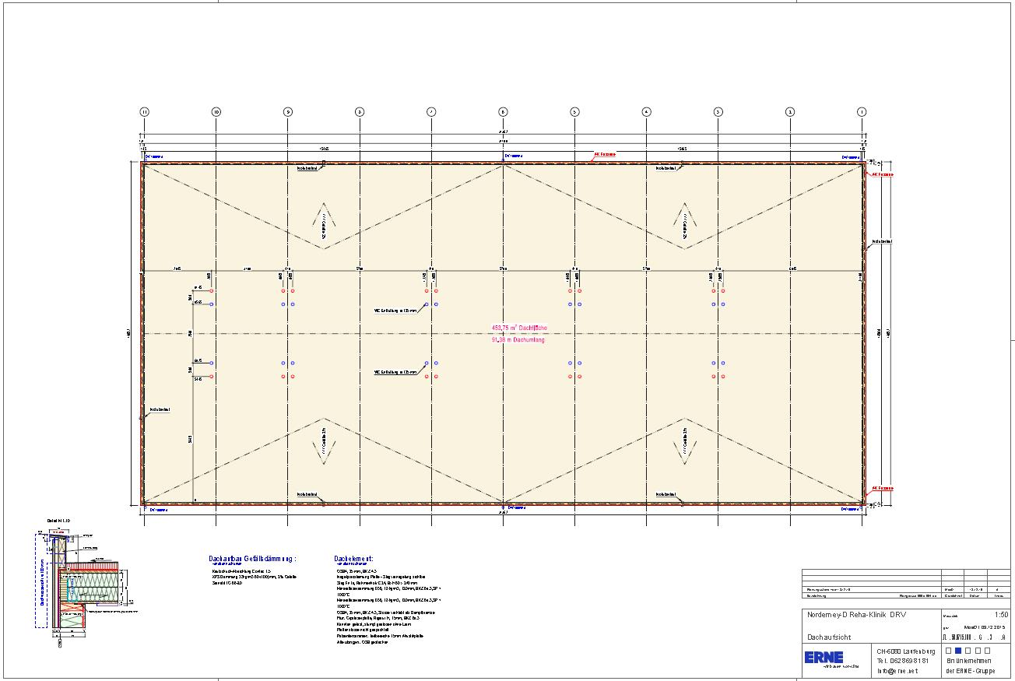
Planning sketches for the interim rehab centre: ground floor, upper floor and roof
(© ERNE AG Holzbau)

About SWISS KRONO GmbH
Originally established as KRONOPLY GmbH in 2000, SWISS KRONO GmbH based in Heiligengrabe, Germany belongs to the SWISS KRONO Group, one of the world’s leading producers of engineered wood products. SWISS KRONO GmbH is one of Europe’s most successful makers of OSB boards. Its other core competencies include MDF and HDF. The company supplies customer-orientated solutions involving innovative products which are backed by comprehensive advice and support. Employing over 700 staff at its site in the German state of Brandenburg, the firm uses wood, a natural raw material, to produce bespoke engineered wood products in full awareness of its responsibility to society.www.swisskrono.de
Press Contact
Ute Bachmann SWISS KRONO GmbH
T +49 176 99938586 Wittstocker Chaussee 1
u.bachmann@werbeagentur-nowack.de 16909 Heiligengrabe
Germany
www.swisskrono.de

