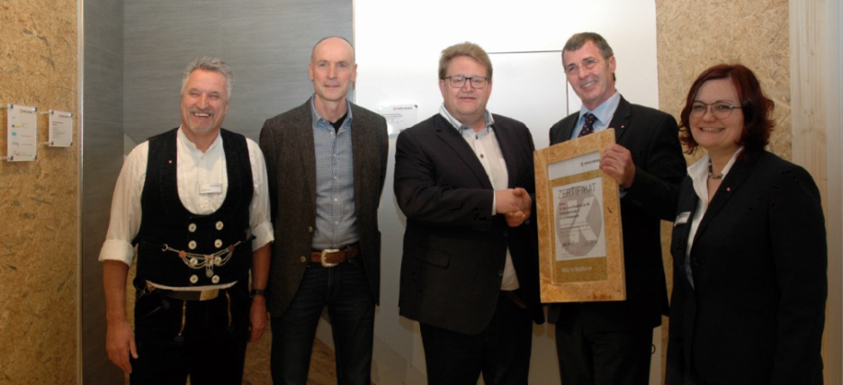

Ch. Borchard Holzwerk New MAGNUMBOARD® OSB Licensee
February 2020 – The firm of Ch. Borchard Holzwerk received the SWISS KRONO certificate for producing MAGNUMBOARD® modules at DACH+HOLZ International 2020, thus becoming an official licensee for this sturdy timber construction system from SWISS KRONO. Managing Director Sven Pietzsch and his authorized deputy, Matthias Weise, formally accepted the document. “We regard MAGNUMBOARD® OSB as an attractive alternative to glulam”, stated Pietzsch. “We are therefore making appropriate investments in order to produce and sell these modules.” Ch. Borchard Holzwerk is spending about 700,000 euros on a Technowood plant for joining SWISS KRONO OSB boards into modules and flexibly prefabricating these with millimetre precision.
The Hildesheim, Germany-based company was established more than 140 years ago. Today its 50+ staff include carpenters, foremen, master craftsmen, technicians and engineers. Ch. Borchard Holzwerk leverages decades of experience and corresponding expertise to fashion the entire spectrum of manual and engineered timber constructions. This includes producing and assembling timber frame structures and truss connector plates and selling windows, doors, parquet and associated accessories on its own account.
“Ch. Borchard Holzwerk have convinced us that they fully meet our requirements for joining our group of licensees”, stated Uwe Jöst, Head of OSB Sales of the SWISS KRONO Group. “Not only due to the firm’s size, but above all because of its many years of experience in flexibly meeting customers’ wishes and the fact that it is equipped with a fleet of state-of-the-art machines.”

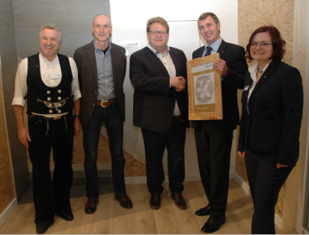 Presentation of the licensing certificate (from left to right): Harald Sauter (SWISS KRONO application technician and master carpenter), Matthias Weise (authorized representative of Ch. Borchard Holzwerk), Sven Pietzsch (managing director of Ch. Borchard Holzwerk), Uwe Jöst (Head of OSB Sales of the SWISS KRONO Group), Carolin Steigemann (SWISS KRONO application technician, Dipl. Ing. (FH) in wood technology) (© SWISS KRONO)

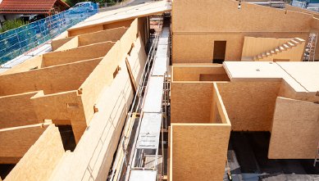 SWISS KRONO MAGNUMBOARD® OSB modules being assembled into a building (© SWISS KRONO │ photographed by tm studios)
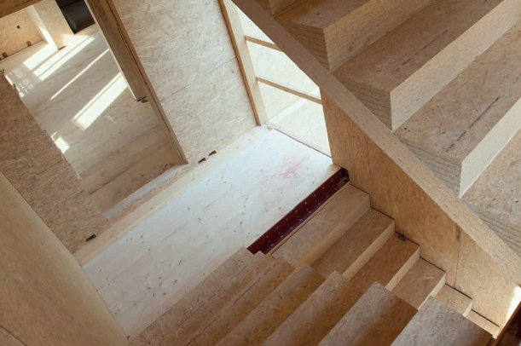 Staircases, doors, windows: MAGNUMBOARD® OSB modules are prefabricated with millimetre precision (© SWISS KRONO │ photographed by Volker Neumann)
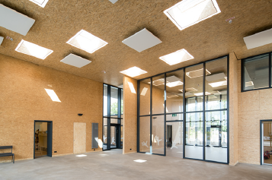 Entrance area of a day-care centre with large-format MAGNUMBOARD® OSB walls (© SWISS KRONO │ photographed by Jan Meier, 190808-220-hr)

About the SWISS KRONO Group
SWISS KRONO Group ranks amongst the world’s leading producers of engineered wood materials and is known for its sustainable and innovative solutions in the product categories of Interior, Flooring and Building Materials. Originally founded in 1966 as a family-run business, today it employs 5,100 staff around the globe. It has its head office in Lucerne, Switzerland and produces at ten locations in eight countries. The SWISS KRONO Group is proud of its long tradition of uncompromising commitment to quality and sustainability: Wood at its best.
Press Contact
SWISS KRONO Group
Katja Hallbauer
Senior Corporate Communications Manager
T +49 30 863 205 30
Katja.hallbauer@swisskrono.com

